The space for this club is very limited. If there is enough interest, I may open up another club on Thursday or Friday. Please read below and answer the questions. Feel free to reach out to me with any questions. Thanks! Erin.Parker@mnps.org

Student Name: ______________________________________________________
Teacher: ___________________________________________________________
Parent Name: _______________________________________________________
Phone Number: _____________________________________________________
My child will be CAR RIDER or TIGER CLUB after Crazy 8’s Club. Car riders will meet in the parking lot on the front left of the school.

The cost for 8 Wednesday sessions will be $150 per child. This will cover supplies, insurance and fees that the club must pay. I will send payment info when I send CONFIRMATION that your child has a spot in this Wednesday club.

PLEASE check an option below!!
___ I am interested in a possible club on THURSDAY and/or FRIDAY should another fall session need to be opened up.
___ My child can ONLY attend on WEDNESDAYS for the fall session.

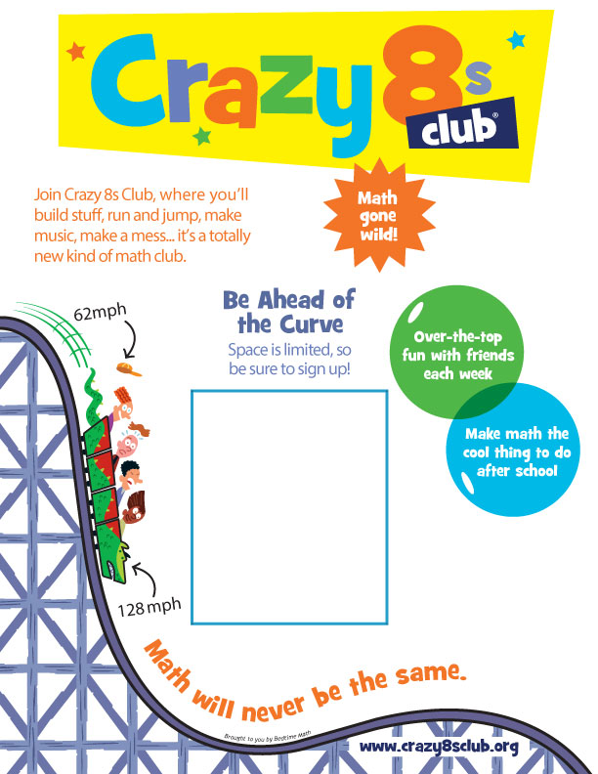
Please see the back of the form for more information and to sign up!
3:00-4:00
Wednesdays Sept. 18-Dec. 3
Mrs. Parker’s Room 15
2nd Grade
Crazy 8s Season #1

